DATA FLOW DIAGRAM EXAMPLE
UMKM Digital Cashier System (Point of Sale)
Derived from: PRD "Sistem Kasir Digital untuk UMKM" v1.0 (20 September 2026)

1. Overview
This document shows how the Product Requirements Document (PRD) for the UMKM Digital Cashier System is translated into a set of Data Flow Diagrams. The PRD states that it serves as the reference for the next modeling stage, including the DFD, so every element below is traced back to a user story (US) or functional requirement (RF) in the PRD.
The diagrams use the Gane & Sarson notation: rounded rectangles for processes, open-ended rectangles for data stores, rectangles for external entities, and labeled arrows for data flows. Three levels are provided: the Context Diagram, the Level 0 DFD, and a Level 1 DFD for the core process "2.0 Process Sales Transaction".
Modeling Assumptions
Only in-scope features from PRD Section 7 are modeled. Tax bookkeeping, mobile app, multi-branch support, and third-party digital payment are out of scope and therefore do not appear.
Stock quantity is stored as an attribute of each product in D1 Product File, because the PRD treats stock as part of product management and monitoring.
The Customer is modeled as an external entity that only receives the purchase receipt (US-03). The customer hands payment to the cashier, who enters it into the system.
Non-functional requirements (performance, encryption, availability) describe how well the system works, so they are not drawn in a logical DFD.

2. Identifying DFD Elements from the PRD

2.1 External Entities
Table 1. External entities identified from the PRD
Entity | PRD source | Role in the system
Cashier | Persona 2 (Andi); US-01 to US-04 | Searches products, enters purchased items and payment, receives totals, change, and low-stock alerts.
Store Owner | Persona 1 (Bu Sari); US-05, US-06 | Maintains product data, restocks items, and receives stock status and sales reports.
Customer | US-03 | Receives the printed purchase receipt as proof of transaction.

2.2 Processes
Table 2. Level 0 processes and their PRD traceability
No. | Process | Related requirements | Description
1.0 | Manage Products | US-06; RF-05 | Add, edit, and delete product data (name, price, stock, minimum stock).
2.0 | Process Sales Transaction | US-01–US-03; RF-01–RF-04 | Search products, build the cart, calculate total and change, record the sale, and print the receipt.
3.0 | Manage Stock | US-04; RF-06 | Reduce stock after each sale, add stock on restock, monitor stock in real time, and issue low-stock alerts.
4.0 | Generate Sales Reports | US-05; RF-07, RF-08 | Produce daily/monthly sales reports and the best-selling items summary.

2.3 Data Stores
Table 3. Data stores
ID | Data store | Main contents | Used by
D1 | Product File | product ID, name, price, stock quantity, minimum stock | 1.0 (write/read), 2.0 (read), 3.0 (read/write)
D2 | Transaction File | transaction ID, date/time, cashier, item lines, total, payment, change | 2.0 (write), 4.0 (read)

3. Context Diagram
The context diagram shows the whole cashier system as one process (numbered 0) and its interaction with the three external entities. As required at this level, there is only one process and no data stores.
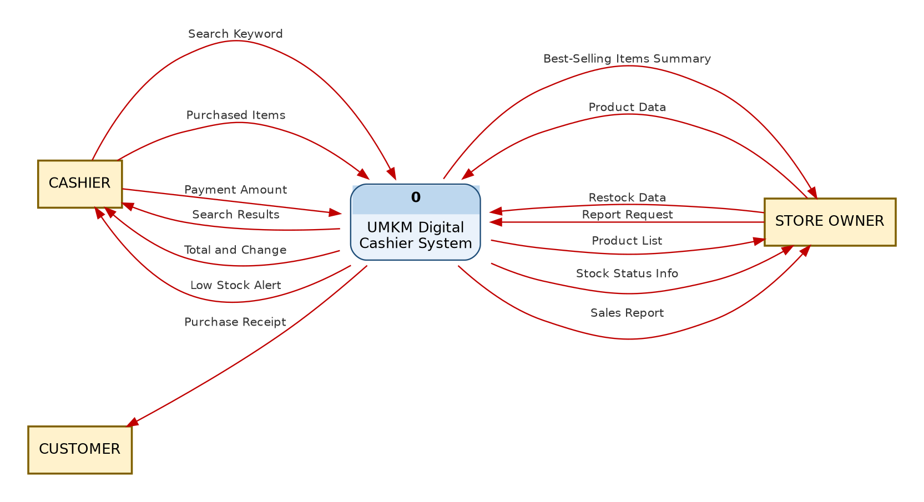
Figure 1. Context diagram of the UMKM Digital Cashier System
Table 4. Data flows in the context diagram
Data flow | Direction | Meaning
Search Keyword | Cashier → System | Product name typed by the cashier (US-01).
Purchased Items | Cashier → System | Selected products and quantities to add to the cart.
Payment Amount | Cashier → System | Cash received from the customer.
Search Results | System → Cashier | List of matching products with price and stock.
Total and Change | System → Cashier | Automatically calculated total and change (US-02).
Low Stock Alert | System → Cashier | Warning when stock falls below the minimum (US-04).
Purchase Receipt | System → Customer | Printed proof of purchase (US-03).
Product Data | Owner → System | New or changed product details, or a delete command (US-06).
Restock Data | Owner → System | Quantity of goods received to add to stock.
Report Request | Owner → System | Chosen report type and period (daily/monthly).
Product List | System → Owner | Current list of products after maintenance.
Stock Status Info | System → Owner | Real-time stock level of each product.
Sales Report | System → Owner | Daily or monthly sales report (US-05).
Best-Selling Items Summary | System → Owner | Ranking of top-selling products (RF-08).

4. Level 0 DFD
The Level 0 DFD explodes process 0 into the four major processes that match the four modules in PRD Section 4 (Transaction, Product, Stock, and Report). The data stores D1 and D2 appear for the first time at this level.
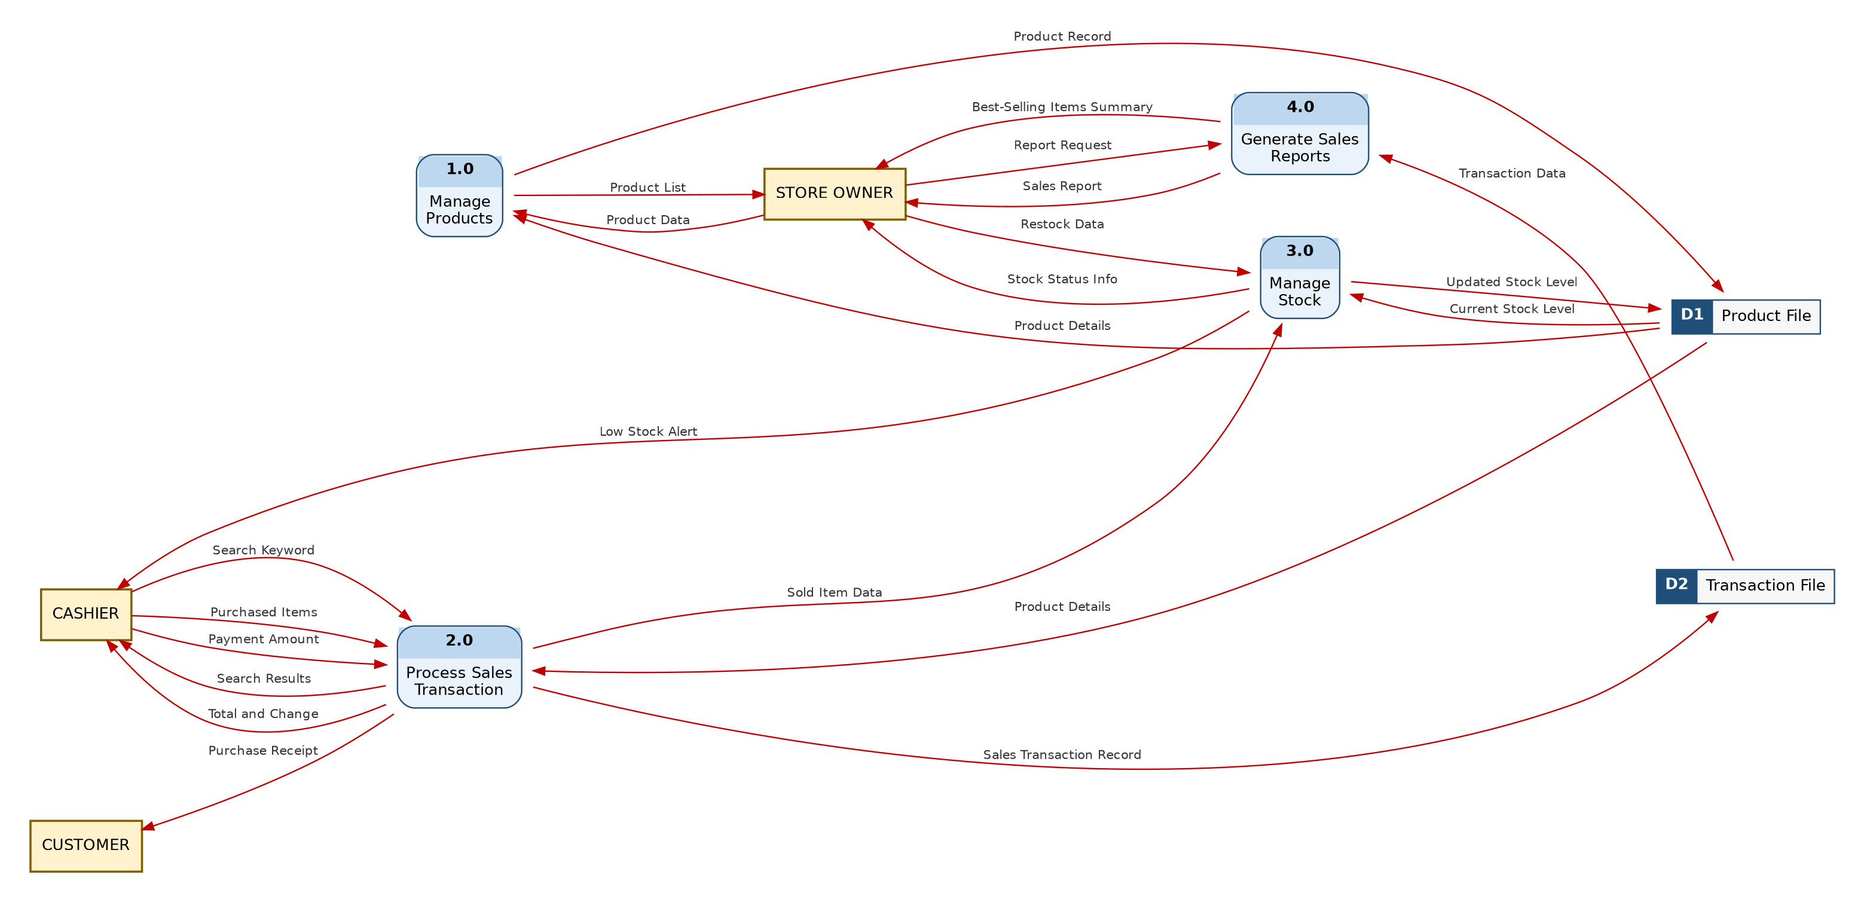
Figure 2. Level 0 DFD of the UMKM Digital Cashier System

4.1 Explanation of Each Process
1.0 Manage Products. The owner sends Product Data. The process writes a Product Record to D1 and reads Product Details back to return an updated Product List to the owner.
2.0 Process Sales Transaction. The cashier sends a Search Keyword, Purchased Items, and the Payment Amount. The process reads Product Details from D1, returns Search Results and the Total and Change, stores a Sales Transaction Record in D2, prints the Purchase Receipt for the customer, and passes Sold Item Data to process 3.0.
3.0 Manage Stock. The process receives Sold Item Data (to reduce stock) and Restock Data from the owner (to increase stock). It reads the Current Stock Level from D1, writes the Updated Stock Level, sends a Low Stock Alert to the cashier when stock is below the minimum, and sends Stock Status Info to the owner.
4.0 Generate Sales Reports. When the owner sends a Report Request, the process reads Transaction Data from D2 and produces the Sales Report and the Best-Selling Items Summary.

5. Level 1 DFD — Process 2.0 Process Sales Transaction
Process 2.0 is the most frequently used and most complex process, so it is decomposed further. The external entities and data stores are shown for readability.
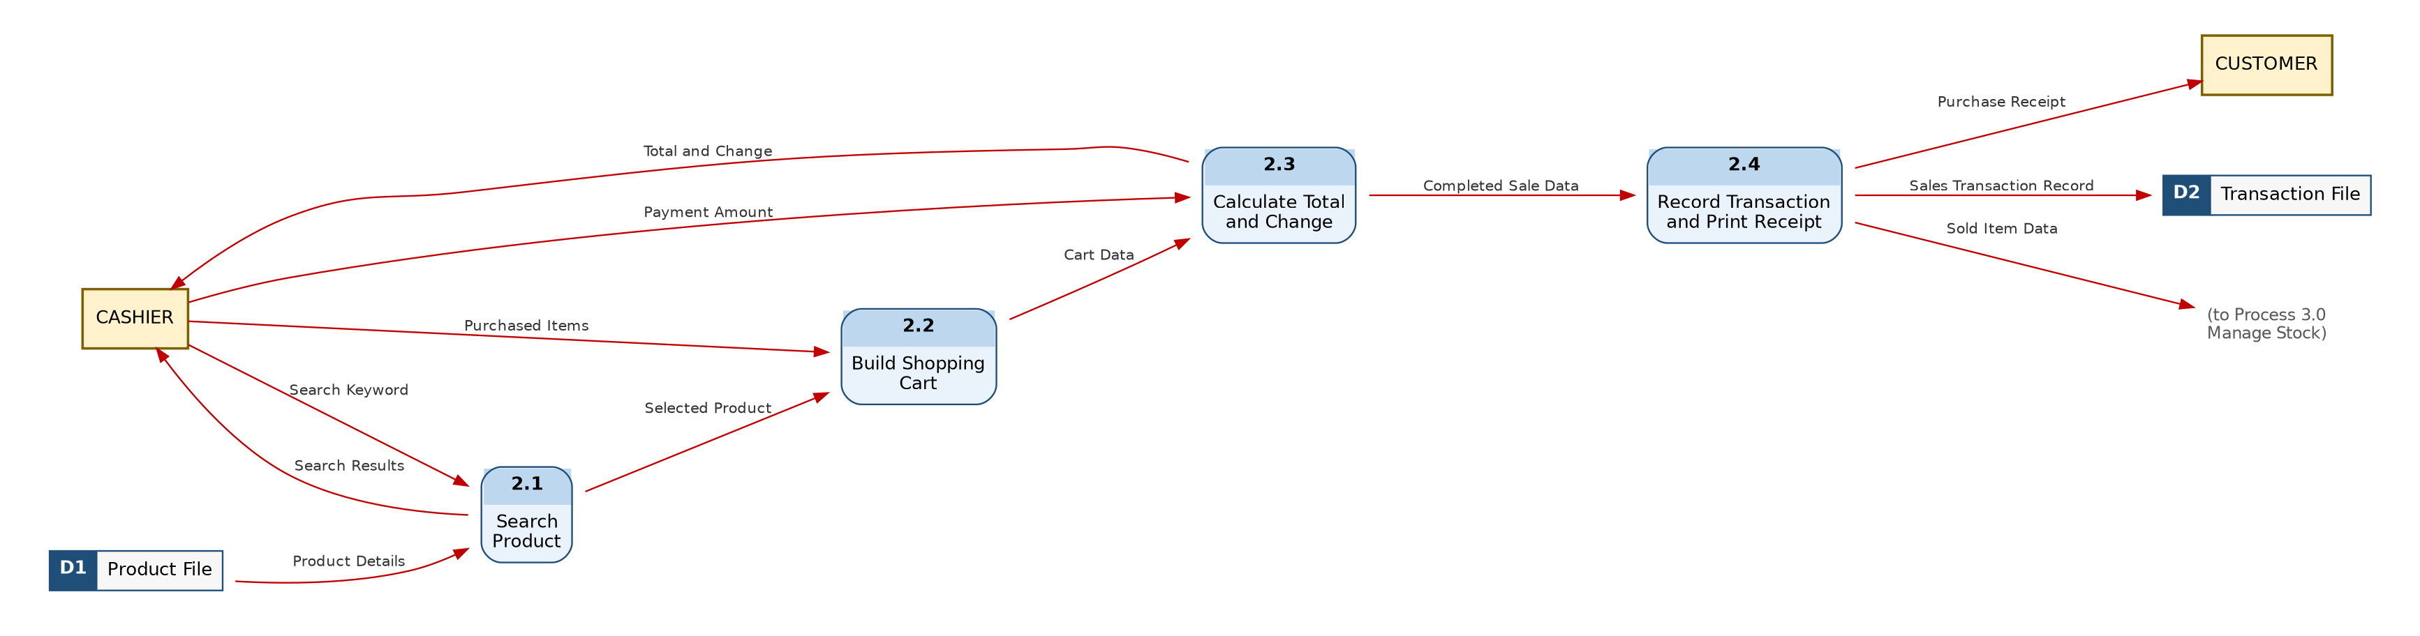
Figure 3. Level 1 DFD of Process 2.0 Process Sales Transaction
Table 5. Sub-processes of Process 2.0
No. | Sub-process | Input | Output
2.1 | Search Product | Search Keyword (Cashier); Product Details (D1) | Search Results (Cashier); Selected Product (2.2)
2.2 | Build Shopping Cart | Selected Product (2.1); Purchased Items (Cashier) | Cart Data (2.3)
2.3 | Calculate Total and Change | Cart Data (2.2); Payment Amount (Cashier) | Total and Change (Cashier); Completed Sale Data (2.4)
2.4 | Record Transaction and Print Receipt | Completed Sale Data (2.3) | Sales Transaction Record (D2); Purchase Receipt (Customer); Sold Item Data (3.0)

Selected Product, Cart Data, and Completed Sale Data are internal flows. They exist only inside process 2.0, so they do not appear at Level 0.

6. Validation

6.1 Balancing Check
Table 6. Balancing between levels
Check | Parent | Child | Result
Context → Level 0 | 3 entities; 6 input flows; 8 output flows | The same 14 flows appear with the same entities | Balanced
Level 0 → Level 1 (inputs of 2.0) | Search Keyword, Purchased Items, Payment Amount, Product Details | Same four inputs | Balanced
Level 0 → Level 1 (outputs of 2.0) | Search Results, Total and Change, Purchase Receipt, Sales Transaction Record, Sold Item Data | Same five outputs | Balanced

6.2 DFD Rules Check
Table 7. Validation against DFD rules
Rule | Result
Every process has at least one input and one output (no miracle / black hole) | Passed
No flow between two data stores, or between an entity and a data store | Passed — all store access goes through a process
No flow directly between two external entities | Passed — payment from customer to cashier happens outside the system
Each arrow has one direction and a noun name | Passed — read and write on D1 are drawn as separate flows
No recursive flow on a process | Passed
Context diagram has one process and no data stores | Passed

6.3 Requirement Coverage
Table 8. Traceability from functional requirements to DFD
Requirement | Covered by
RF-01 Record sales transactions | 2.4 → D2 Sales Transaction Record
RF-02 Calculate total and change automatically | 2.3 Calculate Total and Change
RF-03 Search product by name | 2.1 Search Product
RF-04 Print purchase receipt | 2.4 → Purchase Receipt
RF-05 Manage product data | 1.0 Manage Products
RF-06 Monitor stock and low-stock alert | 3.0 Manage Stock → Low Stock Alert, Stock Status Info
RF-07 Daily and monthly sales reports | 4.0 → Sales Report
RF-08 Best-selling items | 4.0 → Best-Selling Items Summary

All eight functional requirements in the PRD are represented in the DFD.

